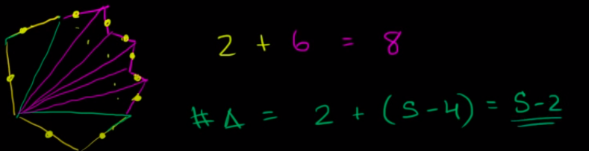
sum of interior angles for ‘s’ sided polygon?
# no of traingles= 2 + ( s – 4)
>>>2- cuz 4 sides creates 2 triangles and every other sides create a unique triangle, thus we have 6 more triangles.
Ans: sum of interior angles = #no of triangles * 180

4 sides makes Two Triangles.

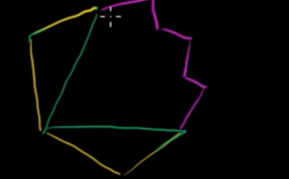
So 4 sides makes 2 triangle and every other side makes a new triangle.
Dont even count the green lines in the left figure

for e.g

sum of exterior angles for a convex polygon?
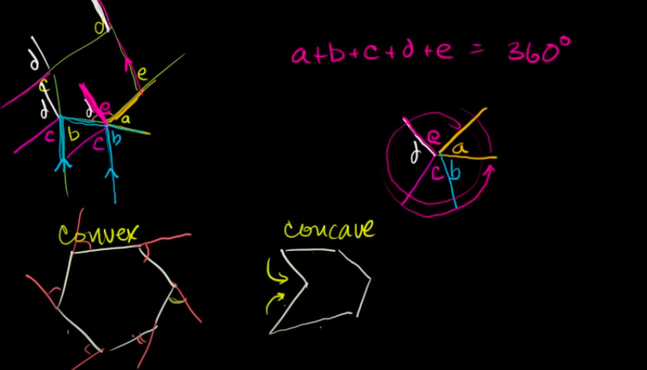
Triangle inequality theorem
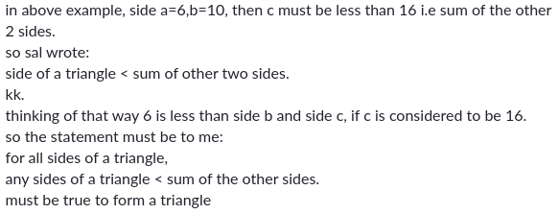
Perpendicular bisector:
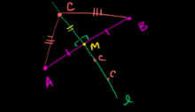
1.It is perpendicular to a segment “AB” and bisects at point “M” | AM=MB.
2.Any point on perpendicular bisector of segment AB is equidistant to Point A , Point B .
3. If a point is equidistant to Point A,Point B of segment AB, then that point must sit on perpendicular
bisector of AB
Circumcenter of a triangle
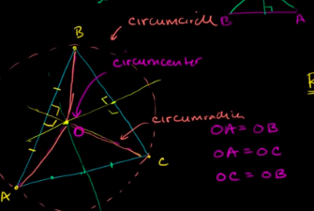
Circumcircle at point “O” circumscribe about Triangle abc.

Circumcenter of a Right triangle
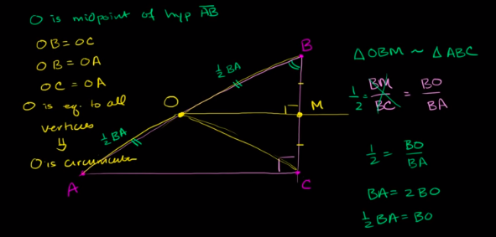
The circumcenter of a Right triangle sits on the hypotoneus of the right triangle.
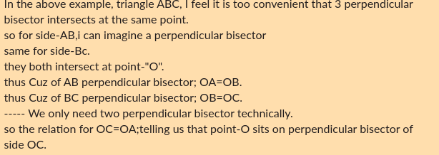
Angle bisector
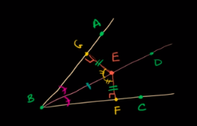
1.here Segment EB bisects the angle ABC equally into
angle ABE, angle EBF.
2. If a points sits on angle bisector of ABC it is equidistant from side AB and side BC.
3.If a point is equidistant from side AB and side BC, it must sit on the angle bisector of ABC.
Incircle, incenter, inradius of a triangle
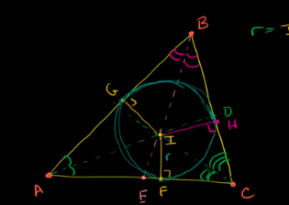

Inradius, perimeter, Area of triangle
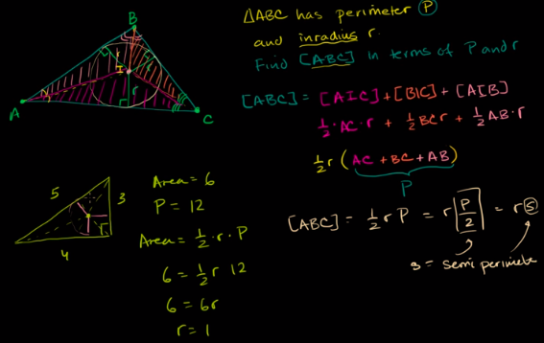

Triangle median, centroid
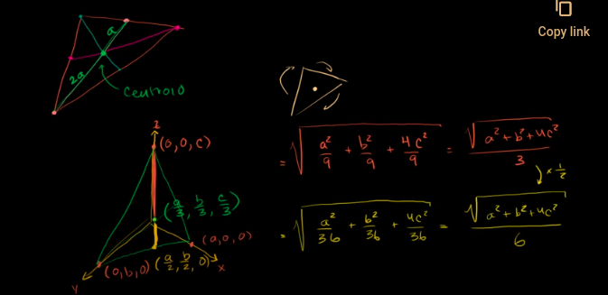

Exploring medial Triangles
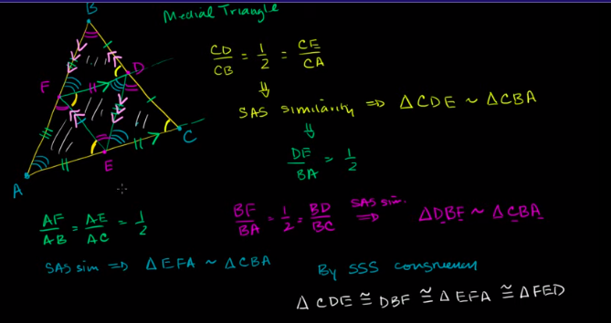
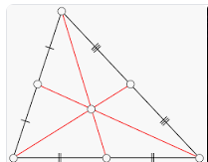

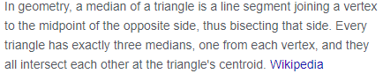

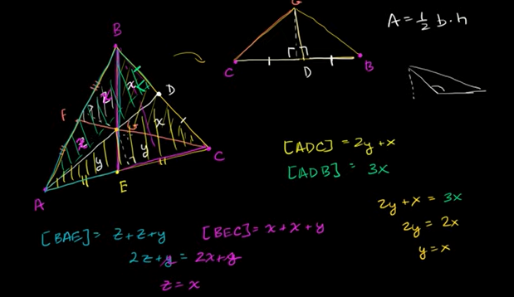

Centroid and median proof
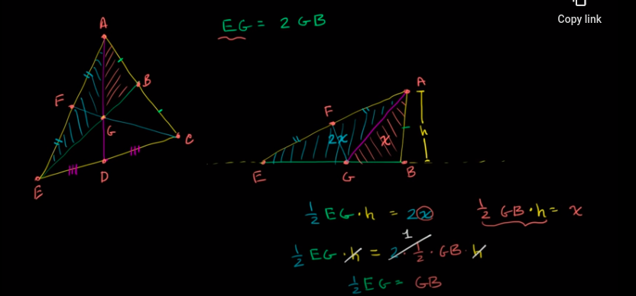
Median centroid exmaple
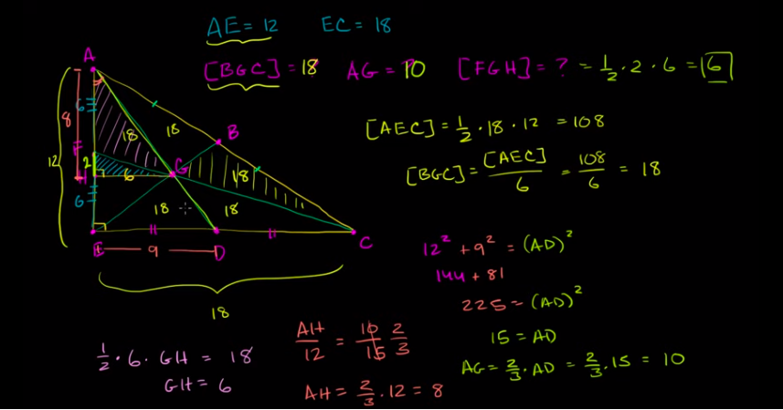
Triangle altitude are concurrent

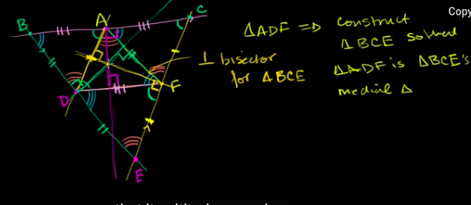

if we start with a triangle, we can also create a triangle that encapsulate our original triangle such that the vertices of our original trinagle is perpendicalur bisector to the side of outer triangle.

Cuz two traversals if you drop a atlitude from original triangle vertice, Alternate angle, plus it is median too so perpendicalur bisector.
Orthocenter is a center where 3 altitude of a triangle intersect.

Common orthocenter and centroid
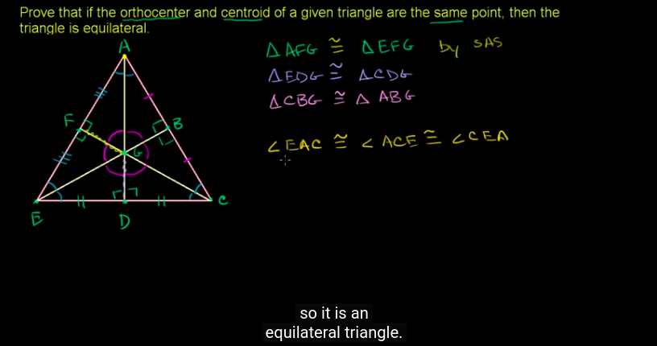

Quadilaterals

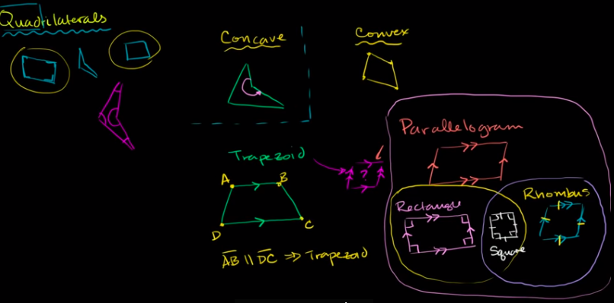
kites

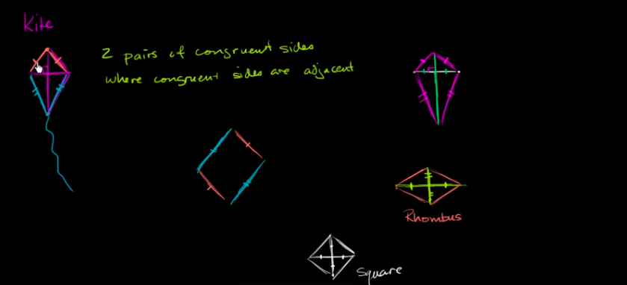
kite: 2 pair of congruent sides where the two congruent sides are adjacent OR a single perpendicular bisector that bisects a segment and then you connect.
Rhombus: Here you have two perpendicular bisector.
Square: Here you have two perpendicular bisector and the diagonals are of same lengths.

Area and unit Squares

Area of a trapezoid
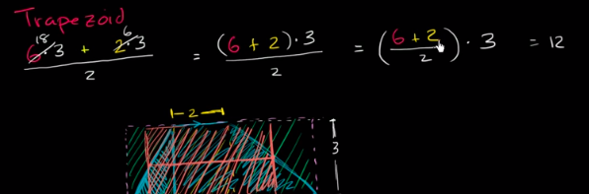
Area of a kite
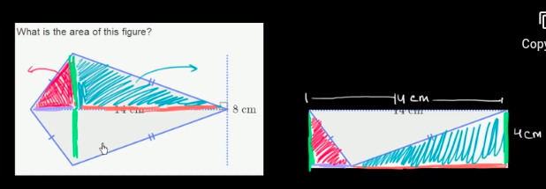
Area and circ umference of a circle.

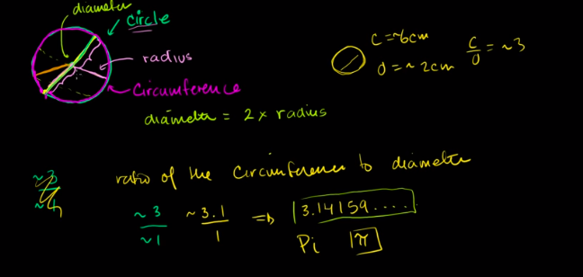

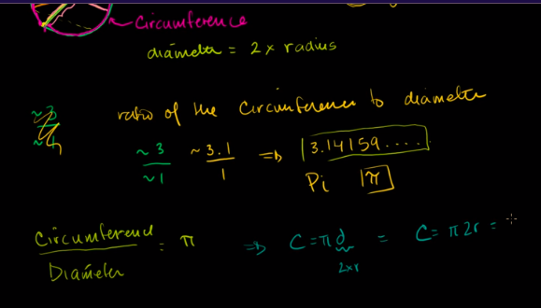
Area of circle intuition

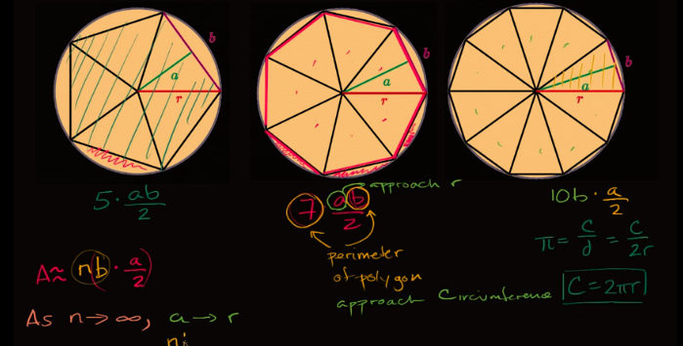

1/2.b.h

2pi*r*r*1/2

pi.r^2

Area of equilateral triangle
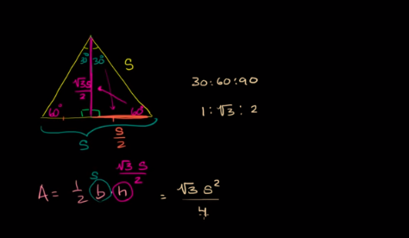

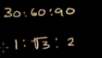
If a triangle is 30,60,90 triangle

so if the side opposite to 30 degree is 1,
then the side opposite to 60 is *
the side opposite to 90 is *

Volume and surface Area

triangular prism:
it has triangle on it sides

rectangular pyramid: it has rectangular or a square base
triangular pyramid: every side is a traingle

Surface area
polyhedra – a 3D shape
The unpacking of polyhedra is called nets
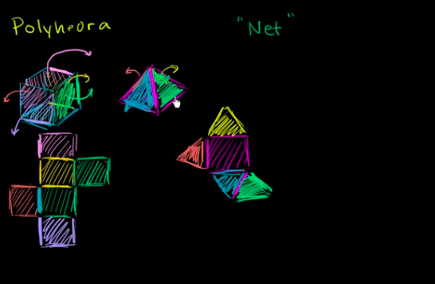

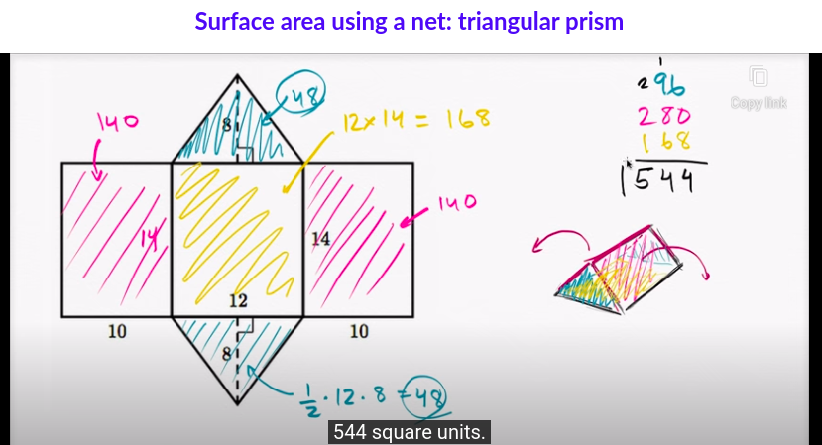
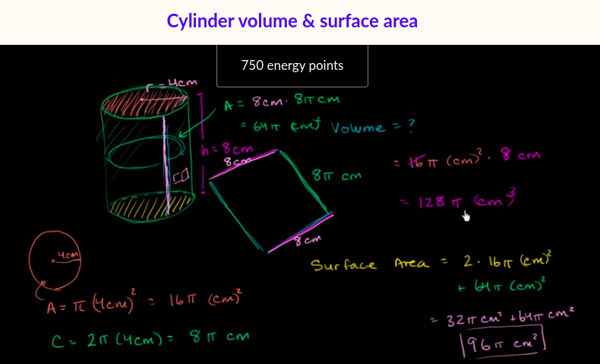
volume of a cylinder= pi . r^2 . h
surface Area = 2.pi.r^2 + 2pi.r.h

Volume of a Cone
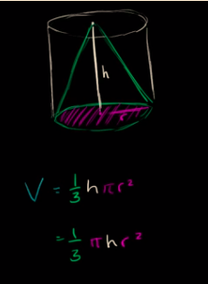

volume of a sphere
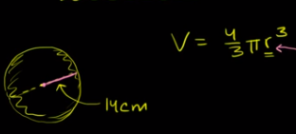

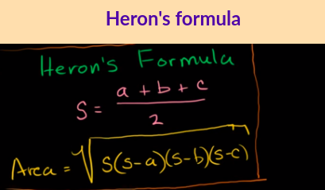

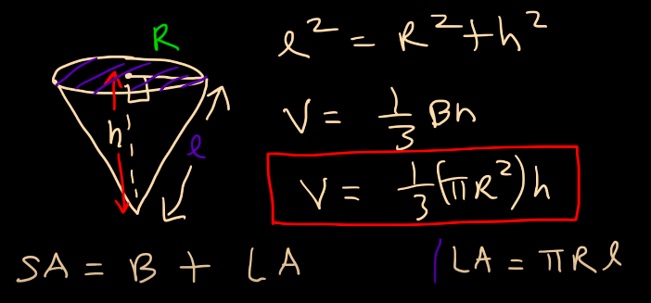
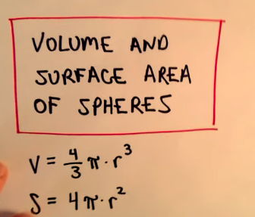
Rigid Transformation

Translation:moving every point in same direction and by the same amt.
Rotation: rotate around a point.
Image of transformation: the set of point after you applied transformation is called.
Reflection:
Rigid Transformation: lengths and angles are preserved

Transformation and congruence
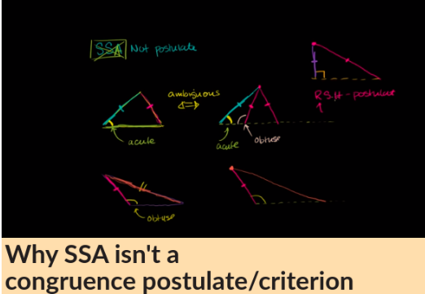

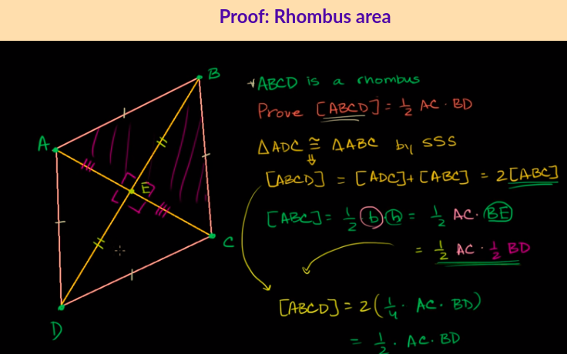

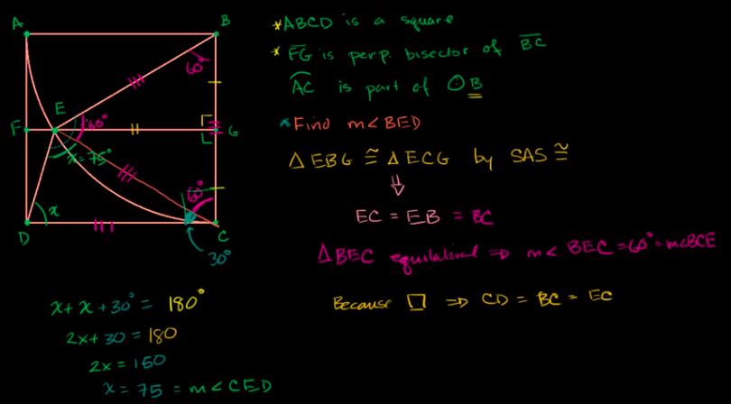
Similarity

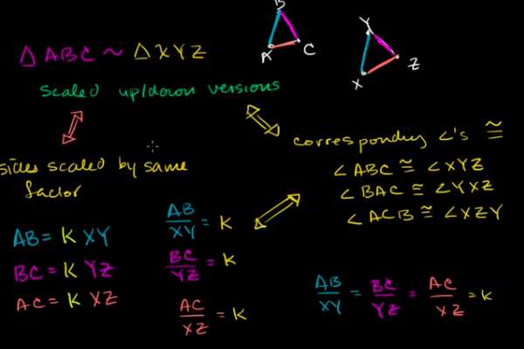

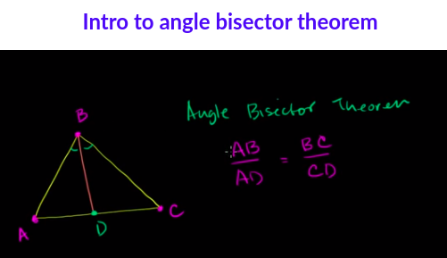
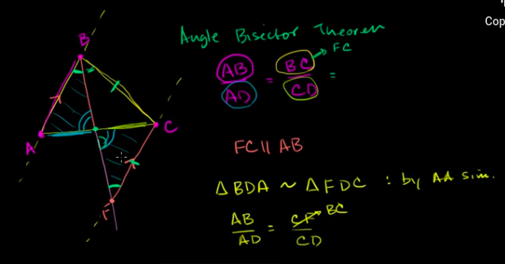

Circle

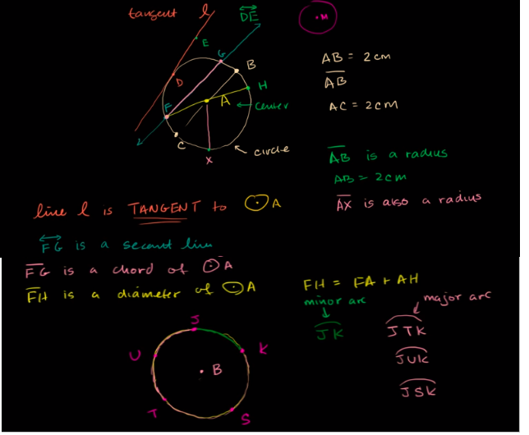
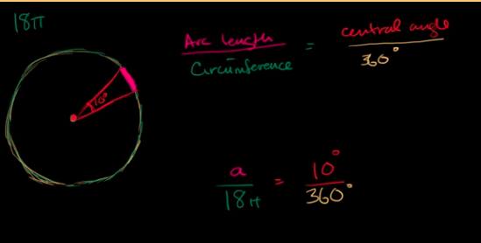

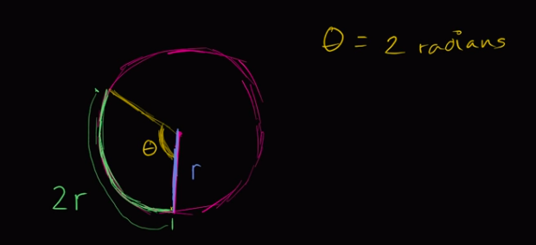
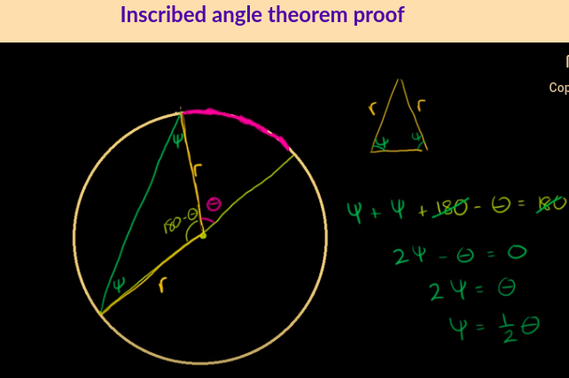

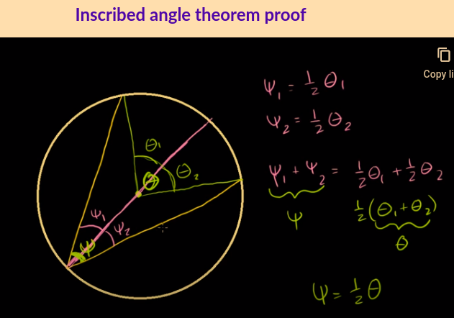
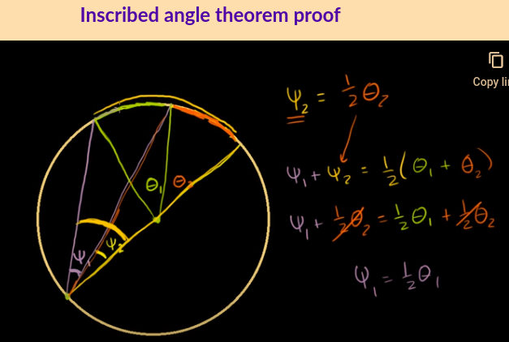

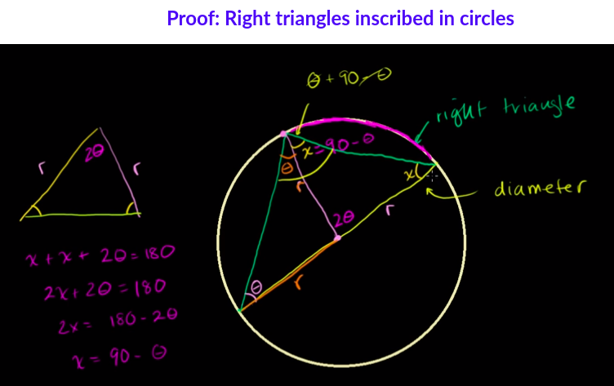
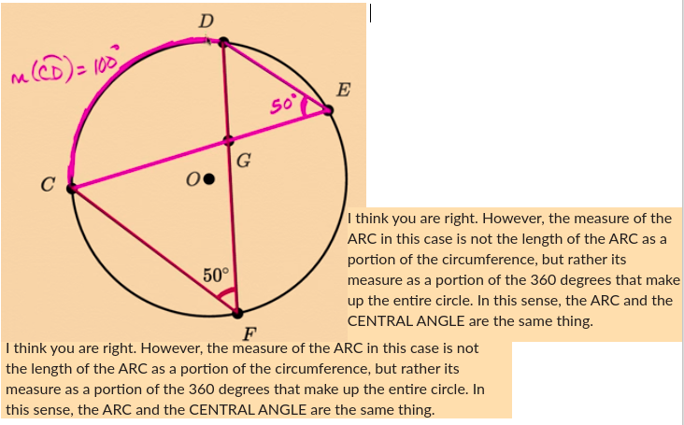
The angle whose opposite side is a diameter is 90 degree angle and the triangle is a Right Triangle

